Assessing Multi-scale Landscape Connectivity Using Network Analysis
Todd R. Lookingbill & Emily S. Minor
Answer Key

Exercise 1. This exercise provides hands on experience building landscape graphs and calculating network statistics. It also explores some theoretical concepts related to species-specific connectivity. Question 2 introduces the concept of the umbrella species.

 | Minimum  habitat  requirement (cells) | Maximum  dispersal  distance (cells) | Largest  component  index | Link  Density  L/[n(n-1)/2]
Small  mammal | 1 | 2 | 0.221; ~0.24
Large  mammal | 16 | 32

Question 1. Which species had the greatest connectivity for the landscape?
Large mammal by both measures.
Largest component index
small mammal: 68 connected habitat/230 total habitat = 0.296
large mammal: 124 connected habitat/124 total habitat = 1.0
Link density
small mammal: 45/(48*47/2) = 0.04
large mammal: 6/(4*3/2) = 1.0

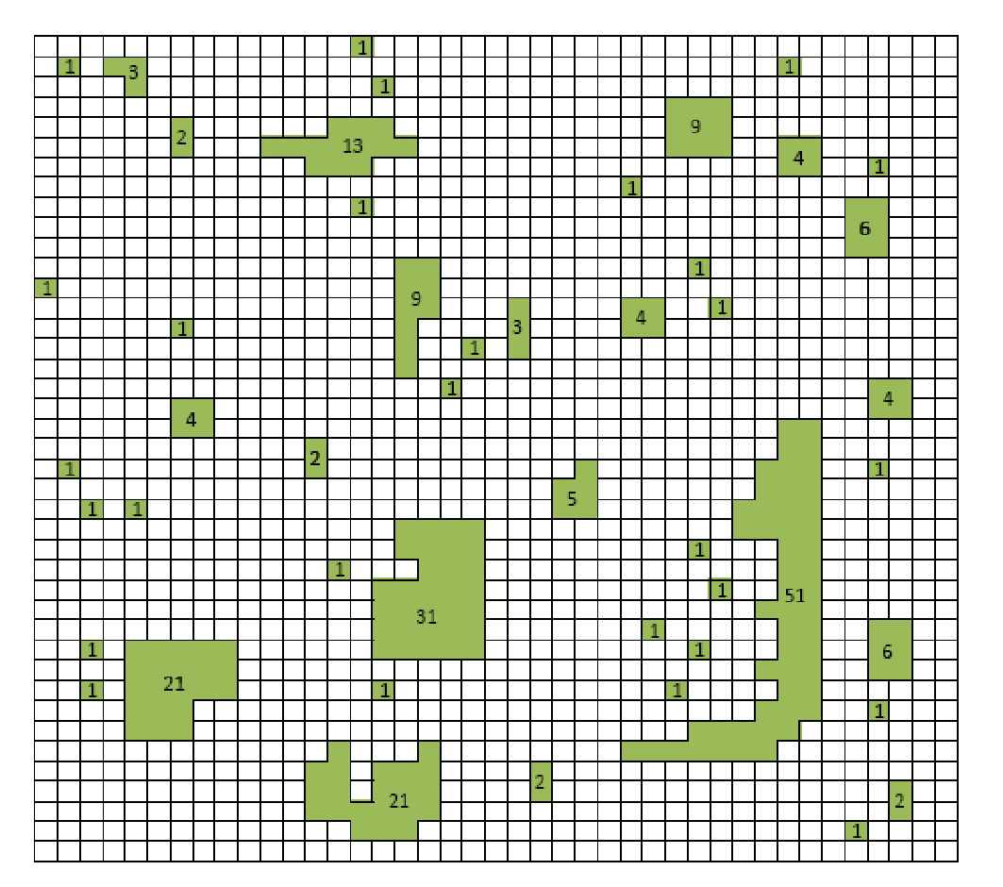
Small mammal network: Large mammal network:

How would the differences in landscape connectivity affect the two species?

Where is the most detrimental place on the landscape to remove habitat?

a) How would the differences in landscape connectivity affect the two species?
The possibility of long-term persistence on the landscape would be greater for the large mammal due to increased potential connectivity of individuals and genes: migration, recolonization, genetic diversity, etc.
Students could also argue that the more connected species is potentially at risk from spread of disease, habitat-destroying disturbance etc. The net benefits of connectivity generally outweigh these negative effects.

b) How might total habitat amount and total number of patches also be important?
What other information would be useful?
The proportion of the landscape comprised of viable habitat (p) is a critical measure for estimating potential persistence and is greater for the small mammal than the large mammal. The largest component index could be high even if p is very low. Similarly, the largest component index could be equally high if the largest component included many small patches or a few large patches, although these two landscapes would differ ecologically.
The quality of habitat (e.g., availability of food/water resources, breeding site), presence of competitors and predators are some examples of additional information that would be useful to have.

Question 2. Define umbrella species.
An umbrella species is a species that, if protected, will indirectly protect many other species. These are typically wide-ranging megafauna with large area requirements.

a) What does this exercise suggest about value of this concept?
The exercise suggests that the umbrella species concept may not be useful when planning for connectivity. It is not possible to generalize that landscapes that are well connected for large "umbrella" species would also be well connected for small mammals (in fact, the opposite was true in this exercise).

b) What specific conservation actions would you recommend for the large mammal?
Small mammal?
Large mammal: protect more large patches (habitat limited)
Small mammal: protect more stepping stone patches (connectivity limited)

Question 3.
a) Where is the most detrimental place on the landscape to remove habitat?
Differs for the two species.
Small mammal: could remove habitat to divide the small mammal's largest component in two (reducing connectivity)
Large mammal: could remove habitat to divide a large patch in two (causing additional habitat fragmentation)

b) Where would be the best place on the landscape to add new habitat?
There are lots of options. This would be a good discussion question for the class to debate the relative merits of their proposals. For example, students could add 3 cells to the 13-cell patch in the north, making it viable for the large mammal and connecting it to the small cluster of cells to its west. The 4th remaining new cell could be added as a stepping stone for the small mammal elsewhere on the graph. Another option might be to connect the 13-cell patch with the 9-cell patch making a much larger patch (of at least 27-cells, depending on how the new cells are distributed).

Exercise 2. This exercise asks students to interpret realistic landscape data to make some management decisions related to connectivity. It starts with two direct interpretation questions that require students to interact closely with the data to ensure they understand the terminology and basic network concepts. These questions are followed by three applied scenarios to motivate further discussion. A follow-up exercise in class could be conducted in which students could be asked to role play the different points of view introduced in questions 6-8 (alternatively, they could be asked to be a conservation advocate for one of the three species) and try to reach consensus on best actions to take to promote (or in cases like the pathologist, reduce) connectivity in the ecoregion.

Question 4. Landscape-level connectivity (Using Table 3)
a) Wolves most connected (highest LCI and LD); mice least (lowest LCI and LD).
b) Matches expectations for hypothetical large and small mammals in Exercise 1

Question 5. Patch-level connectivity (Using Table 4)
a) Foxes most connected (mean Degree = 1.5 and mean Domain = 2.5); mice still least (mean Degree = 1.2 and mean Domain = 2.0).
b) The mouse is most isolated by the measures provided. Could make an argument that should be most concerned about connectivity in general for small mammals like mice.

Question 6. Importance of a specific patch (patch 1) to connectivity (Again using Table 4; now looking at the individual patch values rather than the mean values for the entire landscape)
a) For overall landscape connectivity, patch 1 has as high or higher Domain value than any other patches on the landscape for all three species. Domain is the better of the two patch metrics for measuring landscape-level connectivity; degree measures connectivity at a more local scale.
b) For local dispersal movement, patch 1 has the highest Degree value for the fox, but not the other two species. Patch 5 is higher for the mouse, and patch 58 is higher for the wolf.

Question 7. Where to add foxes to maximize their rapid dispersal to other patches?
Might want to maximize degree for rapid dispersal to many new patches (the most local metric). Patch 1 has highest degree for fox; it also has the largest area, which would be another desirable attribute.
It's also reasonable to choose the highest domain first to find the largest component, and then select the highest degree within that component. This approach would also end up selecting patch 1.

Question 8. Where would you focus control actions to limit the spread of a mouse-bourne disease throughout the ecoregion?
This question is meant to highlight the fact that connectivity is not always a good thing and that these same tools can be used to develop methods for disrupting connectivity. Patch 5 has high importance to the connectivity of mice on the landscape and would be a logical choice.

Table 4 missing answers:
Mouse Fox Wolf
Node
1 2 9 4 6 1 2
63 2 2 1 1 1 2
66 0 0 1 1
75 0 0 0 0

The synthesis questions are intended to get students to consider some of the simplifying assumptions in the prior exercises (e.g., the role of the matrix for connectivity, what types of landscape features would create hard barriers to movement) and speculate on how the network approach could be applied to topics related to connectivity in wetland, riverine, and ocean environments. For a graduate student lab, instructors may want to emphasize written responses to the Synthesis Questions and focus less on responses to Exercise 1. However, conducting the hand calculations in Exercise 1 should still be useful. Undergraduate instructors may prefer a greater focus on Exercise 1 (than the Synthesis).

Synthesis Questions

Question 9.
An implicit assumption that was made about the matrix when constructing these networks was that the landscape was spatially homogeneous and all cells were of equivalent difficulty (i.e., “resistance”) for movement. In reality, the landscape is a mosaic of different land covers, some of which may impede movement more than others. For example, a road or river could act as a barrier to dispersal regardless of a species’ maximum dispersal distance.

Question 10.
See Figure 3. (1) To reach the southern two-thirds of the ecoregion from this patch, an organism would have to move through Portland. (2) The organism would also have to cross over the Columbia River or Multnomah Canal to get off the island. Instructors may want to reference the following relevant website. http://landcovertrends.usgs.gov/west/eco3Report.html

Question 11.
a) The road would eliminate some links for some species. Slow moving species that spend part of their lives in water and part on land like turtles or salamanders would have difficulty crossing the road.
b) Again, some of the links could be lost; species that desiccate easily could be affected by the increased sun exposure and not attempt to cross the logged landscape. The logging could also affect the wetland patches themselves. For example, there might be increased runoff and sedimentation.
c) First, the wetlands themselves should be avoided. The potential loss of habitat area is important not to overlook in a discussion of connectivity. Edge effects should also be considered. Then all of the connectivity issues discussed in the lab should be considered to try to locate the actions such that they minimally reduce the size of the network.

Question 12.
a) For example, streams have flow and therefore directional graphs might be required for passive dispersers (i.e., movement from patch A to patch B might not equal movement from patch B to patch A).
b) Marine environments also have directionality due to currents and tides. Depth would be a critical third dimension to consider in ocean environments. For both streams and marine environments, connectivity might depend upon season, which affects movement of water.
c) The best option to increase connectivity (e.g., the closest potential reserve site to other existing sites) might not also be the site of highest quality in terms of habitat or species richness. Tough decisions and trade-offs are often required in reserve network design.

